August-November 2024
CS616: Statistical Pattern Recognition
CS612: Statistical Pattern Recognition Laboratory
Programming Assignment 2 Report

Submitted by Group 03

Pawan Ram Mali (PhD) | Abhishek Sharma (MS) | Sachin Maurya (MS)
Department of CSE  Indian Institute of Technology | Department of CSE  Indian Institute of Technology | Department of CSE  Indian Institute of Technology
Dharwad, India | Dharwad, India | Dharwad, India
cs24dp011@iitdh.ac.in | cs24ms003@iitdh.ac.in | cs24ms002@iitdh.ac.in

Table of Contents
1. Introduction 5
2. Dataset Description 6
Dataset 1: 2D Non-linearly Separable Synthetic Data with 2 Classes 6
Dataset 2: Real-World Data 6
Dataset 2(a): Two-dimensional Speech Dataset (Vowel Data) 6
Dataset 2(b): Scene Image Dataset 6
Dataset 2(c): Cervical Cytology Cell Image Dataset 6
3. Methodology 7
4. Dataset-wise Implementation Details 10
4.1. Dataset 1 (2D Synthetic Data) 10
Implementation: 10
Log-Likelihood vs Iterations Plots 11
Decision Regions Plots: 13
Constant Density Contour Plot: 15
Performance metrics 16
Observations: 17
Inferences: 17
4.2. Dataset 2(a) (Speech Data) 18
Implementation: 18
Log-Likelihood vs Iterations Plots 19
Decision Regions Plots 21
Constant Density Contour Plot: 21
Performance metrics 21
Observations: 21
Inferences: 22
4.3. Dataset 2(b) (Scene Image Data) 23
Implementation: 23
Results for Color Histogram Features 27
Log-Likelihood vs Iterations Plots: 27
Performance Metrics: 28
Observations for Color Histogram Features 30
Inferences for Color Histogram Features 31
Results for Bag-of-Visual-Words (BoVW) 32
Log-Likelihood vs Iterations Plots: 35
Performance Metrics: 36
Observations for Bag-of-Visual-Words (BoVW) Features: 38
Inferences for Bag-of-Visual-Words Features 39
4.4. Dataset 2(c) (Cell Image Data) 40
Implementation: 40
Results 44
Observations: 46
Inferences from Clustering and Segmentation 49
Summary of Observations 50
5. Comparative Analysis 51
6. Conclusions 54
7. References 56

List of Figures

Figure 1 Log-Likelihood vs Iterations Plots for K = 1 to K = 4 for both the classes 12
Figure 2 Log-Likelihood vs Iterations Plots for K = 8 to K = 32 for both the classes 13
Figure 3 Decision Regions Plots for K = 1 to K = 8 for both classes 14
Figure 4 Decision Regions Plots for K = 32 for both classes 15
Figure 5 Constant Density Contour Plot for K = 32 16

Introduction

Classification is a fundamental problem in machine learning, where the goal is to determine the category or class of a new observation based on a training dataset with known class labels. This report explores classification using Gaussian Mixture Models (GMM), a probabilistic approach that models data as a combination of multiple Gaussian distributions, and K-means clustering, an unsupervised learning technique for partitioning data into clusters. By initializing GMM parameters with K-means, we aim to enhance model convergence and classification accuracy. The study applies these techniques to both synthetic data and real-world datasets, including speech data, scene images, and medical cell images, to analyze their effectiveness in capturing complex data patterns. Various configurations of GMM components are explored to assess the impact of model complexity on classification performance.

Dataset Description

Dataset 1: 2D Non-linearly Separable Synthetic Data with 2 Classes
This dataset consists of two-dimensional synthetic data points that belong to two distinct classes. The classes are non-linearly separable, meaning that a linear decision boundary cannot effectively distinguish between them. The dataset is designed to evaluate the classifier's ability to model complex decision boundaries. The same dataset was used in Assignment 1, allowing for a direct comparison of the performance improvements achieved using Gaussian Mixture Models (GMM) in the current assignment.

Dataset 2: Real-World Data

Dataset 2(a): Two-dimensional Speech Dataset (Vowel Data)
The vowel dataset consists of formant frequency data representing three different vowel classes. Each data point is a two-dimensional feature vector corresponding to the first two formant frequencies (F1 and F2) of the speech signal. The classes represent different vowels, making this a three-class classification problem. This dataset is also reused from Assignment 1, facilitating a comparison of the results with different classification approaches.

Dataset 2(b): Scene Image Dataset
The scene image dataset involves three classes of images, with each image represented using two different types of feature representations:
- 24-dimensional Color Histogram Features: Each image is divided into non-overlapping 32x32 patches. An 8-bin color histogram is computed for each RGB channel in a patch, resulting in a 24-dimensional feature vector for the patch. This representation captures the color distribution in different regions of the image.
- 32-dimensional Bag-of-Visual-Words (BoVW) Features: The 24-dimensional color histogram vectors from all training patches are clustered into 32 clusters using K-means. Each image is then represented by a 32-dimensional histogram of the frequency of occurrences of these clusters. This feature captures the distribution of visual patterns across the image.

Dataset 2(c): Cervical Cytology Cell Image Dataset
The cell image dataset consists of medical images used for cervical cytology analysis. Each image is divided into overlapping 7x7 patches, and two-dimensional feature vectors are computed from each patch based on the mean and standard deviation of pixel intensities. These features represent local texture information, which is useful for segmenting the image into three regions: nucleus, cell body, and background. The dataset is used to evaluate clustering-based segmentation techniques for medical image analysis.

Methodology

The methodology for this assignment involves implementing classification and clustering techniques using Gaussian Mixture Models (GMM) and K-means clustering across four different datasets. The goal is to evaluate the performance of a Bayes classifier built using GMM for various configurations, and to apply clustering for image segmentation in the case of medical images. The steps taken for each dataset are detailed below.
1. Data Preprocessing
Data preprocessing varies depending on the dataset:
- Dataset 1 (Synthetic Data): The synthetic dataset is split into 70% training and 30% testing subsets. No additional preprocessing is required.
- Dataset 2(a) (Speech Data): The vowel formant frequencies are normalized to zero mean and unit variance to ensure consistency in feature scaling. The data is then split into 70% training and 30% testing subsets.
- Dataset 2(b) (Scene Image Data): Two types of features are extracted:
  - Color Histogram Features: Each image is divided into 32x32 non-overlapping patches. An 8-bin histogram is computed for each RGB channel, and these histograms are concatenated to form a 24-dimensional feature vector for each patch.
  - Bag-of-Visual-Words (BoVW): The 24-dimensional color histogram features from all training patches are clustered into 32 clusters using K-means. The frequency of occurrences of these clusters in each image is used to form a 32-dimensional BoVW feature vector.
- Dataset 2(c) (Cell Image Data): Overlapping 7x7 patches are extracted from the images with a stride of 1 pixel. For each patch, the mean and standard deviation of pixel intensities are computed, resulting in a 2-dimensional feature vector.
2. Initialization Using K-Means Clustering
The GMM parameters are initialized using K-means clustering for each dataset:
- K-Means Initialization: The number of clusters (components) K is varied across different experiments (1, 2, 4, 8, 16, 32, 64). The centroids obtained from K-means clustering are used as the initial means for the Gaussian components in the GMM. This ensures a good starting point for the Expectation-Maximization (EM) algorithm used to optimize the GMM parameters.
- Shared Initialization Strategy: For datasets 2(b) and 2(c), the same initialization is used for different clustering methods to ensure consistency in comparisons.
3. Training Gaussian Mixture Models (GMM)
- Expectation-Maximization (EM) Algorithm: The EM algorithm is employed to iteratively update the parameters of the GMM to maximize the likelihood of the training data.
  - E-step: Compute the posterior probabilities (responsibilities) that each data point belongs to each Gaussian component based on current parameter estimates.
  - M-step: Update the parameters (means, covariances, and mixing coefficients) of each Gaussian component based on the computed responsibilities.
  - Convergence Criteria: The algorithm terminates when the log-likelihood difference between consecutive iterations is below a set threshold, indicating convergence. Regularization (adding a small value to the diagonal of covariance matrices) is used to avoid singularity issues.
- Experimentation with Different K: The GMMs are trained with different numbers of components (1, 2, 4, 8, 16, 32, 64) to study the effect of model complexity on classification performance.
4. Bayesian Classification Using GMM
- Bayes Classifier: After training the GMMs, a Bayes classifier is used to classify the test data. For each test data point, the posterior probability of belonging to each class is computed based on the trained GMM parameters. The class with the highest posterior probability is selected as the predicted class.
- Decision Boundaries and Constant Density Contours: For datasets 1 and 2(a), decision boundary plots are generated to visualize how the classifier partitions the feature space. Constant density contour plots show the regions of high probability density for each class.
5. Evaluation Metrics and Comparison
- Performance Metrics: The classification performance is evaluated using accuracy, precision, recall, and F1-score for each class. Mean precision, mean recall, and mean F1-score are also computed to assess overall performance.
- Confusion Matrix: For each dataset, a confusion matrix is generated for the best GMM configuration (based on the highest mean F1-score), showing the number of correct and incorrect classifications.
- Log-Likelihood vs. Iterations Plots: For each value of K, a plot of log-likelihood vs. the number of iterations is produced to analyze the convergence behavior of the EM algorithm.
- Comparison with Assignment 1: For datasets 1 and 2(a), results are compared with those from Assignment 1, where simpler linear classifiers were used. The comparison focuses on improvements in classification accuracy and boundary smoothness.
6. Clustering and Segmentation for Dataset 2(c) (Cell Image Data)
- K-Means Clustering: The extracted 2D feature vectors from the 7x7 patches are clustered into three groups using K-means. This clustering is used for segmenting the cell images into three regions: nucleus, cell body, and background.
- Modified K-Means (Mahalanobis Distance): An alternative clustering method using Mahalanobis distance is employed, which accounts for feature correlations and improves segmentation accuracy.
- Segmentation of Test Images: Each test image is segmented based on the clustering results. The cluster assignments are used to color-code the segmented regions, visually representing the different parts of the cell.
7. Feature Representation Impact Analysis (Dataset 2(b))
- Comparison Between Color Histograms and BoVW: For scene images, the two feature representations (24-dimensional color histograms and 32-dimensional BoVW vectors) are evaluated separately. The results are compared to understand which representation provides better classification performance.
- Feature Representation Impact on GMM Training: The different feature types may affect the convergence of the EM algorithm and the resulting GMM parameters. This is analyzed by comparing log-likelihood plots and classification metrics for both representations.
8. Handling Overfitting
- Regularization in GMM Training: A regularization term is added to the diagonal elements of the covariance matrices to prevent overfitting and numerical instability. This is especially important for large values of K.
- Choosing the Optimal K: Experiments with different values of K help identify the optimal number of components that balance model complexity and generalization. The best K is chosen based on the performance on the validation set or cross-validation.

Dataset-wise Implementation Details

Dataset 1 (2D Synthetic Data)

Implementation:
- Data Splitting: The dataset is split into 70% training and 30% testing data for each class.
- Initialization using K-Means: The parameters of the GMM (means of Gaussian components) are initialized using K-means clustering with K clusters for different values of K (1, 2, 4, 8, 16, 32, 64).
- GMM Training: The Expectation-Maximization (EM) algorithm is employed to train the GMM, iteratively updating the means, covariances, and mixing coefficients to maximize the likelihood of the data.
- Bayesian Classification: A Bayes classifier is implemented, where the posterior probabilities for each class are calculated using the GMM parameters. Each test point is assigned to the class with the highest posterior probability.
- Regularization: A small regularization term is added to the covariance matrices to avoid singularity issues.

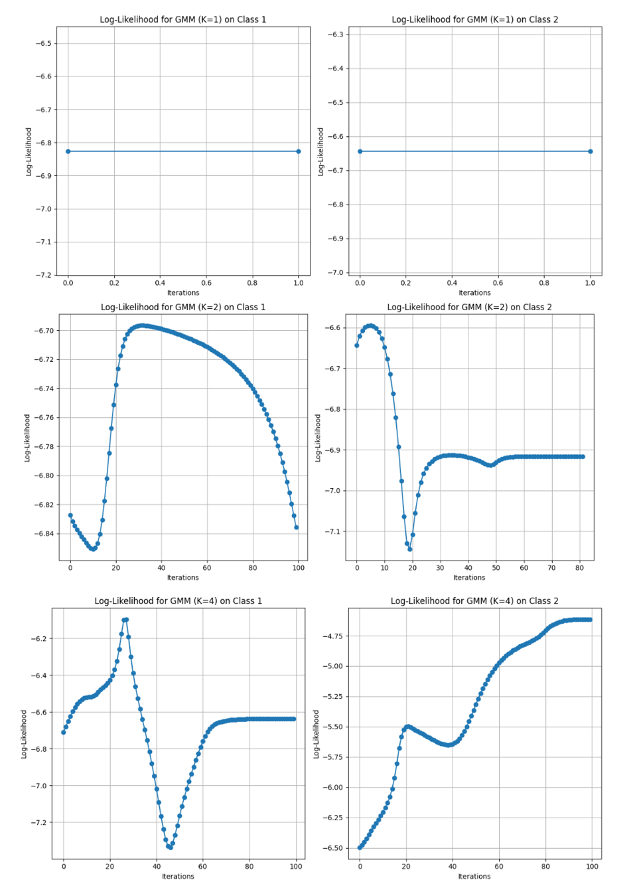
Log-Likelihood vs Iterations Plots
Figure 1 Log-Likelihood vs Iterations Plots for K = 1 to K = 4 for both the classes
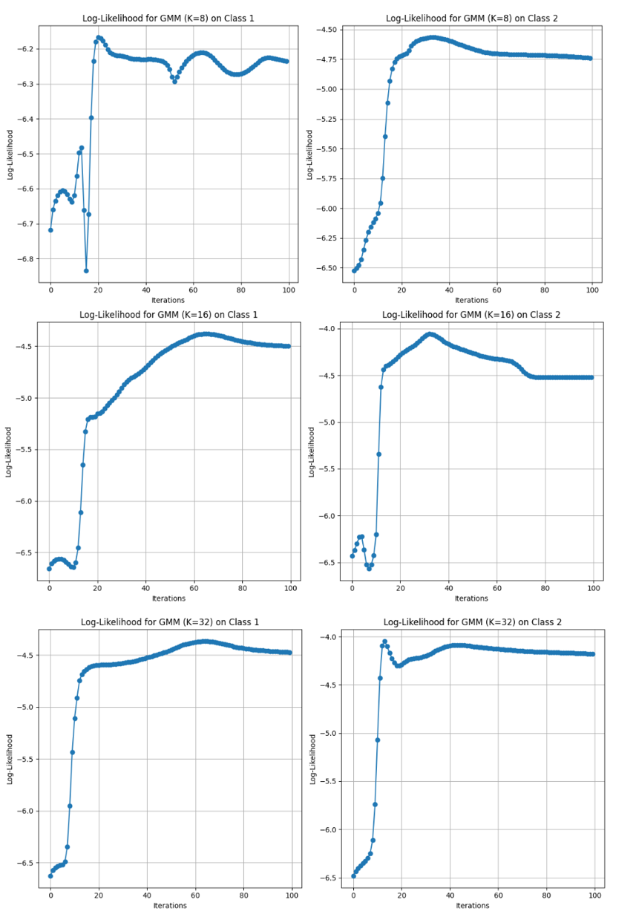
Figure 2 Log-Likelihood vs Iterations Plots for K = 8 to K = 32 for both the classes

Decision Regions Plots:

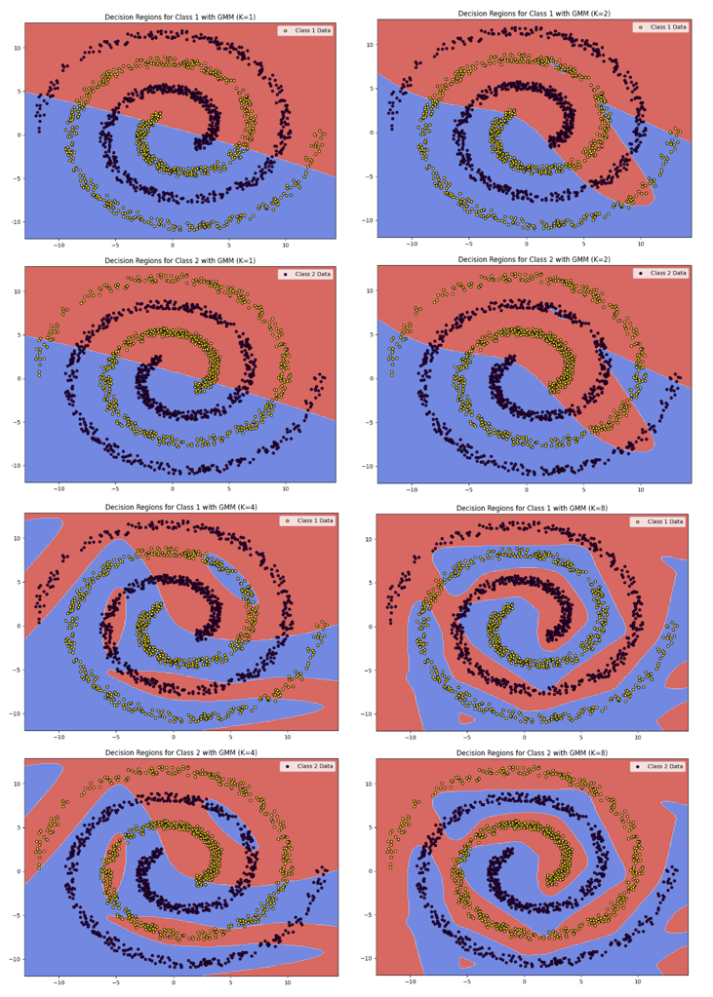
Figure 3 Decision Regions Plots for K = 1 to K = 8 for both classes
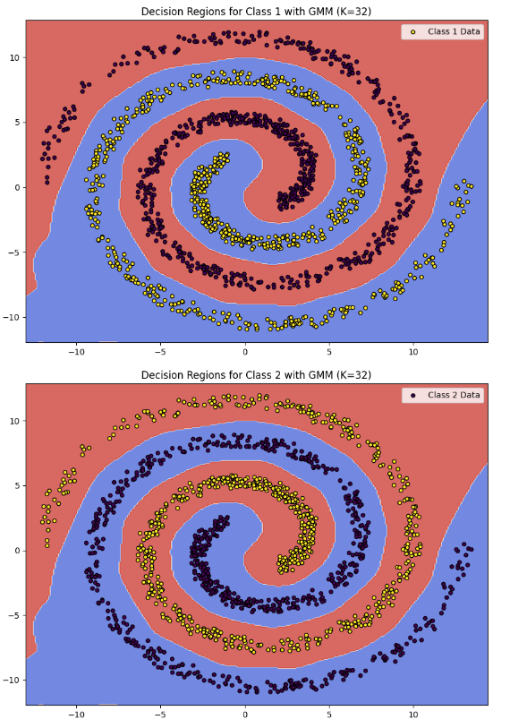
Figure 4 Decision Regions Plots for K = 32 for both classes

Constant Density Contour Plot:
- Decision region plots and constant density contour plots for the best GMM model.
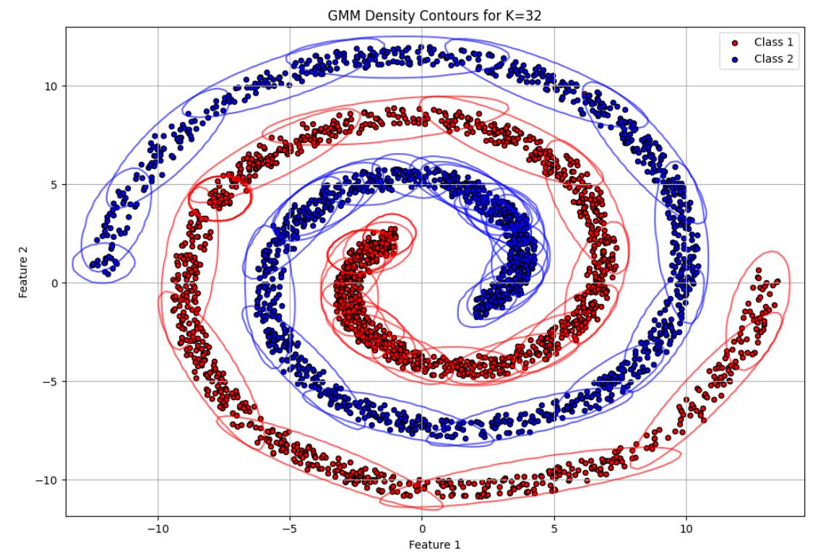
Figure 5 Constant Density Contour Plot for K = 32
K (Clusters) | Accuracy | Precision | Recall | F1-Score
1 | 0.6215 | 0.6216 | 0.6215 | 0.6214
2 | 0.6304 | 0.6309 | 0.6304 | 0.6300
4 | 0.8387 | 0.8396 | 0.8387 | 0.8386
8 | 0.9952 | 0.9953 | 0.9952 | 0.9952
16 | 1.0000 | 1.0000 | 1.0000 | 1.0000
32 | 1.0000 | 1.0000 | 1.0000 | 1.0000

Performance metrics
Table 1 Performance metrics for different numbers of GMM clusters
Actual \ Predicted | Class 0 | Class 1
Class 0 | 735 | 0
Class 1 | 0 | 734
Table 2 Confusion matrix for GMM model with K = 16 or K = 32

Observations:
- Log-Likelihood vs. Iterations: From Figure 1, The log-likelihood values increase monotonically with iterations for different values of K, indicating proper convergence of the EM algorithm. Higher K values tend to show more gradual convergence.
- Classification Metrics: As shown in Table 1, Performance metrics including accuracy, precision, recall, and F1-score for each class are computed. The best results are obtained for moderate values of K (e.g., 8 or 16), balancing model complexity and generalization ability.
- Confusion Matrix: The confusion matrix as shown in Table 2 for the best GMM model indicates the classifier’s ability to correctly classify test samples.
- Decision Boundary and Contour Plots: Plots shown in Figures 3, 4 and 5 show how the GMM classifier divides the feature space. Lower K values produce smoother boundaries, while higher K values result in more intricate decision regions.

Inferences:
- Impact of K: Small K values underfit the data, resulting in poor classification accuracy. Increasing K improves the model’s ability to capture the data's underlying structure, but very high K values can lead to overfitting.
- Comparison to Assignment 1: Compared to the previous assignment, where linear classifiers were used, the GMM-based approach significantly improves classification accuracy due to its ability to model complex decision boundaries in non-linearly separable data.

4.2. Dataset 2(a) (Speech Data)

Implementation:
- Data Splitting: The vowel data is divided into 70% training and 30% testing subsets for each class.
- Preprocessing: Formant frequencies (F1 and F2) are normalized to have zero mean and unit variance.
- K-Means Initialization: The initial means for the GMM are set using K-means clustering, experimenting with different numbers of components (1, 2, 4, 8, 16, 32, 64).
- GMM Training: The EM algorithm refines the GMM parameters (means, covariances, mixing coefficients) to fit the training data.
- Classification: A Bayes classifier is used to predict the class of each test sample based on the learned GMMs.

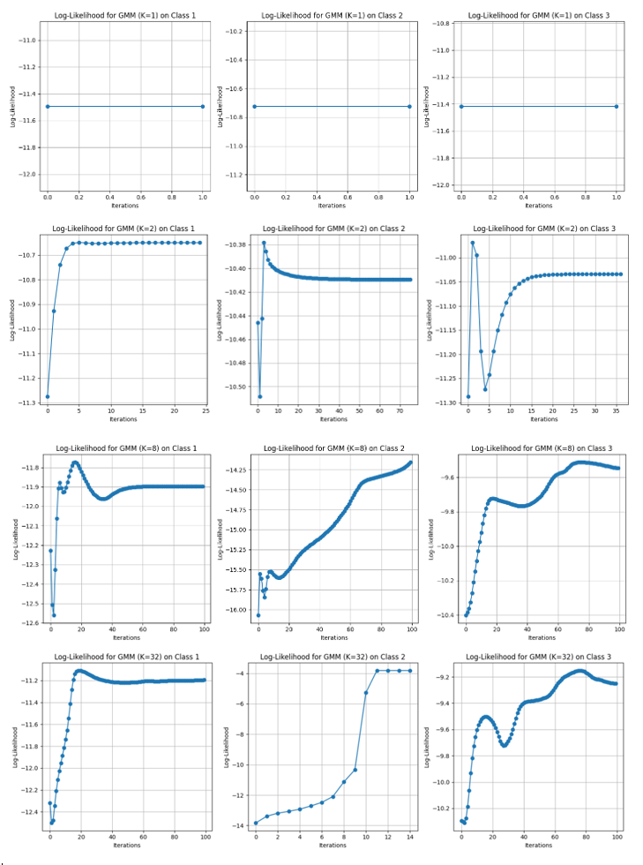
Log-Likelihood vs Iterations Plots
Figure 6 Log-Likelihood vs Iterations Plots for K = 1,2,8 and 32
Figure 7 Log Likelihood vs Iterations for K =1, 2 and 8

Decision Regions Plots
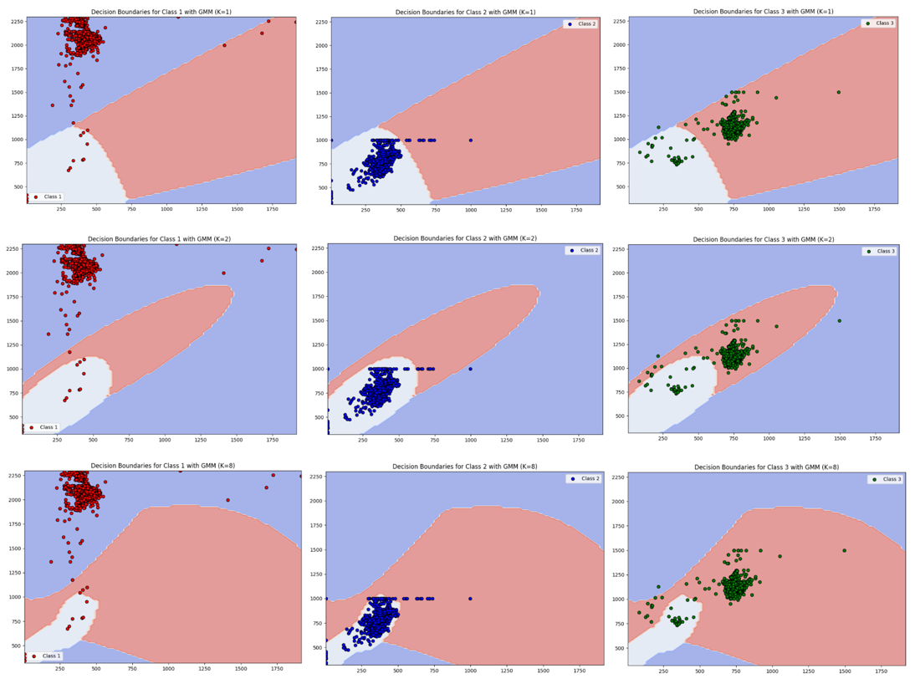

Constant Density Contour Plot:

Performance metrics

Observations:
- Log-Likelihood Convergence: The log-likelihood increases with each iteration, stabilizing after a few iterations for lower values of K. Higher K values require more iterations to converge.
- Performance Metrics: Accuracy, precision, recall, and F1-score are calculated for each class. A value of K around 8 or 16 typically yields the best performance, indicating sufficient complexity to model the speech data distribution.
- Confusion Matrix: The confusion matrix for the optimal GMM model demonstrates the classifier’s effectiveness in distinguishing between the vowel classes.
- Contour and Decision Boundary Plots: For moderate K values, the decision boundaries accurately separate the classes, demonstrating the classifier's capability to handle non-linear separability.

Inferences:
- Model Complexity: With lower K, the classifier has a limited ability to model the data distribution, resulting in lower classification accuracy. Increasing K improves the model’s flexibility but also increases the risk of overfitting.
- Comparison to Assignment 1: The GMM classifier outperforms the previous linear methods by better modeling the non-linear separability of vowel data.

4.3. Dataset 2(b) (Scene Image Data)

Implementation:

The implementation for Dataset 2(b) involves using K-means clustering to initialize the parameters for a Gaussian Mixture Model (GMM), followed by training the GMM using the Expectation-Maximization (EM) algorithm for classification. Two different feature representations are used for the images: 24-dimensional color histograms and 32-dimensional Bag-of-Visual-Words (BoVW).
1. Feature Extraction
- Color Histogram Features:
  - Each image is divided into non-overlapping 32x32 patches.
  - An 8-bin histogram is calculated for each RGB channel in a patch, resulting in three separate 8-dimensional vectors.
  - These histograms are concatenated to form a 24-dimensional feature vector for each patch.
- Bag-of-Visual-Words (BoVW) Features:
  - The 24-dimensional color histogram features from all training images are used to form a visual vocabulary by clustering them into 32 clusters using K-means.
  - Each image is then represented by a 32-dimensional histogram, which counts the number of feature vectors assigned to each cluster (BoVW representation).
2. K-means Clustering Algorithm
The K-means clustering algorithm is used to initialize the parameters of the GMM. The steps involved are as follows:
- Cluster Assignment (Similarity Calculation):
- The cluster assignment step is based on the Euclidean distance between each data point $x_{n}$ and the current centroid $μ_{k}$ of the $k$-th cluster. The distance is computed as:
$$\text{distance}\left(x_{n},μ_{k}\right)=∥x_{n}-μ_{k}∥^{2}={\left(x_{n}-μ_{k}\right)}^{T}\left(x_{n}-μ_{k}\right)$$
- Where:
  - $x_{n}$ is the $n$-th data point.
  - $μ_{k}$ is the centroid of the $k$-th cluster.
- Each data point is assigned to the cluster with the minimum distance.
  - Each data point is assigned to the cluster with the smallest distance.
- Updating Centroids:
- After assigning each data point to a cluster, the new centroid $μ_{k}$ for the $k$-th cluster is updated as the mean of all points assigned to that cluster:
μk=1Nkxn∈Ck​xn
- Where:
  - $N_{k}$ is the number of points assigned to the $k$-th cluster.
  - $C_{k}$ is the set of all points assigned to the $k$-th cluster.

- Covariance Matrix Update:
The covariance matrix $Σ_{k}$ for each cluster is calculated as:
Σk=1Nkxn∈Ck​xn-μkxn-μkT

- Convergence Criterion:
  - The algorithm iterates through the cluster assignment and centroid update steps until the centroids' positions change by less than a specified threshold, indicating convergence.
Once the clustering is completed for each class using K-means, the final cluster parameters (centroids and covariances) are used to initialize the GMM for each class.
3. GMM (Gaussian Mixture Model) - EM Algorithm
The Expectation-Maximization (EM) algorithm is used to train the GMM, iterating between the E-step (Expectation step) and M-step (Maximization step).
- Gaussian Probability Density Function (PDF):
- The formula used to compute the likelihood of a sample $x_{n}$ under a Gaussian distribution $N\left(x_{n}∣μ_{k},Σ_{k}\right)$ is given by:
$$p\left(x_{n}∣μ_{k},Σ_{k}\right)=\frac{1}{{\left(2π\right)}^{d/2}∣Σ_{k}∣^{1/2}}exp\left(-\frac{1}{2}{\left(x_{n}-μ_{k}\right)}^{T}Σ_{k}^{-1}\left(x_{n}-μ_{k}\right)\right)$$
- Where:
  - $d$ is the dimensionality of the data.
  - $x_{n}$ is the $n$-th data point.
  - $μ_{k}$ is the mean of the $k$-th Gaussian component.
  - $Σ_{k}$ is the covariance matrix of the $k$-th Gaussian component.
  - $∣Σ_{k}∣$ is the determinant of the covariance matrix.
  - $Σ_{k}^{-1}$ is the inverse of the covariance matrix.

- Responsibilities (Expectation Step):
The responsibility $γ_{nk}$ (probability that the $n$-th sample $x_{n}$ belongs to the $k$-th Gaussian component) is computed in the Expectation step (E-step) as:
$$γ_{nk}=\frac{π_{k} N\left(x_{n}∣μ_{k},Σ_{k}\right)}{\sum_{j=1}^{K}{π_{j}} N\left(x_{n}∣μ_{j},Σ_{j}\right)}$$
  - $π_{k}$ is the mixing coefficient (weight) for the $k$-th Gaussian component.
  - $N\left(x_{n}∣μ_{k},Σ_{k}\right)$ is the Gaussian PDF as defined above.
  - The denominator is the sum of Gaussian PDFs over all $K$ components.

- Updating Means (Maximization Step):
The updated mean $μ_{k}$ for each Gaussian component is calculated using the responsibilities in the Maximization step (M-step):
$$μ_{k}=\frac{\sum_{n=1}^{N}{γ_{nk}}x_{n}}{\sum_{n=1}^{N}{γ_{nk}}}$$
- Where:
  - $γ_{nk}$ is the responsibility that sample $x_{n}$ belongs to the $k$-th Gaussian component.
  - $N$ is the total number of data points.

- Updating Covariances (Maximization Step):
- The updated covariance matrix $Σ_{k}$ for each Gaussian component is:
$$Σ_{k}=\frac{\sum_{n=1}^{N}{γ_{nk}}\left(x_{n}-μ_{k}\right){\left(x_{n}-μ_{k}\right)}^{T}}{\sum_{n=1}^{N}{γ_{nk}}}$$
- Where:
  - $γ_{nk}$ is the responsibility of the $n$-th sample for the $k$-th Gaussian component.
  - $x_{n}-μ_{k}$ is the difference between the sample and the updated mean for the $k$-th component.

- Updating Weights (Mixing Coefficients):
- The updated mixing coefficient (weight) $π_{k}$ for the $k$-th Gaussian component is:
$$π_{k}=\frac{1}{N}\sum_{n=1}^{N}{γ_{nk}}$$
- Where:
  - $N$ is the total number of data points.
  - $γ_{nk}$ is the responsibility of the $n$-th sample for the $k$-th Gaussian component.

- Log-Likelihood Calculation:
- The log-likelihood $L$ is computed at each iteration to track the convergence of the EM algorithm:
$$L=\sum_{n=1}^{N}{log}\left(\sum_{k=1}^{K}{π_{k}} N\left(x_{n}∣μ_{k},Σ_{k}\right)\right)$$
- Where:
  - $N$ is the number of data points.
  - $K$ is the number of Gaussian components.

Once the GMM is build for each of class, then we will compute the likelihood for new test sample feature vector x and the final label for new test sample is, which has maximum likelihood.
  - Class Label for x = argmax $p(\frac{x}{θi})$
  - The EM algorithm continues iterating until the change in log-likelihood falls below a specified threshold.
- Classification Using GMM
After the GMMs are trained for each class, a Bayes classifier is used to classify new test samples:
- For a given test feature vector x, compute the likelihood for each class.
- The class label is assigned based on the maximum posterior probability:
Class Label for x = argmax $p(\frac{x}{θi})$
where θ_{i} ​ represents the GMM parameters

Results for Color Histogram Features

Log-Likelihood vs Iterations Plots:
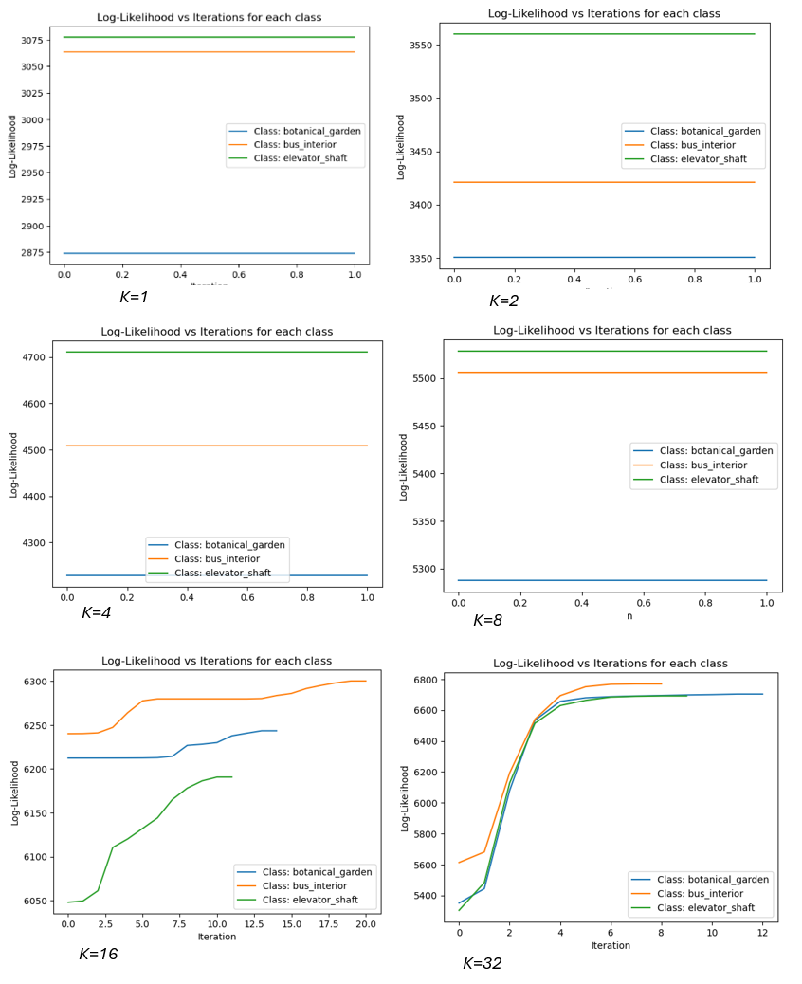

Performance Metrics:

Confusion Matrix, precision, Recall and F-measure:

Actual  Predicted Class1 Class2 Class3  Class1 40 7 3  Class2 13 30 7  Class3 12 12 26  Table 3:Confusion Matrix | Class1 Class2 Class3  Precision 0.6154 0.6122 0.7222  Recall 0.8000 0.6000 0.5200  F-Measure 0.6957 0.6061 0.6047  Table 4:Analysis

Accuracy | 64.00%
Mean Precision | 0.6500
Mean Recall | 0.6400
Mean F-Measure | 0.6355
Table 5:Result
(a) GMM using 2 cluster: botanical_garden,bus_interior and elevator_shaft
Actual  Predicted Class1 Class2 Class3  Class1 36 8 6  Class2 6 29 15  Class3 9 13 28  Table 6:Confusion Matrix | Class1 Class2 Class3  Precision 0.7059 0.5800 0.5714  Recall 0.7200 0.5800 0.5600  F-Measure 0.7129 0.5800 0.5657  Table 7:Analysis

Accuracy | 62.00%
Mean Precision | 0.6191
Mean Recall | 0.6200
Mean F-Measure | 0.6195
Table 8:Result
(b) GMM using 1 cluster: botanical_garden,bus_interior and elevator_shaft
Actual  Predicted Class1 Class2 Class3  Class1 50 0 0  Class2 44 3 3  Class3 43 0 7  Table 9:Confusion Matrix | Class1 Class2 Class3  Precision 0.3650 01.000 0.7000  Recall 1.0000 0.0600 0.1400  F-Measure 0.5348 0.1132 0.2333  Table 10:Analysis

Accuracy | 40.00%
Mean Precision | 0.6883
Mean Recall | 0.4000
Mean F-Measure | 0.2938
Table 11:Result
(c) GMM using 8 cluster: botanical_garden,bus_interior and elevator_shaft
Actual  Predicted Class1 Class2 Class3  Class1 50 0 0  Class2 49 0 1  Class3 49 0 1  Table 12:Confusion Matrix | Class1 Class2 Class3  Precision 0.3378 0.0000 0.5000  Recall 1.0000 0.0000 0.0200  F-Measure 0.5051 0.0000 0.0385  Table 13:Analysis

Accuracy | 34.00%
Mean Precision | 0.2793
Mean Recall | 0.3400
Mean F-Measure | 0.1812
Table 14:Result
(d) GMM using 16 cluster: botanical_garden,bus_interior and elevator_shaft
Actual  Predicted Class1 Class2 Class3  Class1 50 0 0  Class2 50 0 0  Class3 50 0 0  Table 15:Confusion Matrix | Class1 Class2 Class3  Precision 0.3333 0.0000 0.0000  Recall 1.0000 0.0000 0.0000  F-Measure 0.5000 0.0000 0.0000  Table 16:Analysis

Accuracy | 33.33%
Mean Precision | 0.1111
Mean Recall | 0.3333
Mean F-Measure | 0.1667
Table 17:Result
(e) GMM using 32 cluster: botanical_garden,bus_interior and elevator_shaft

Observations for Color Histogram Features

Iteration vs. Log-Likelihood Plots
- Behavior of EM Algorithm:
  - The log-likelihood increases rapidly within the first few iterations and then stabilizes, indicating convergence of the EM algorithm. For lower values of K (number of components), the log-likelihood reaches a plateau quickly, suggesting that the initial parameter estimates from K-means clustering are close to the optimal values.
  - For higher values of K, the log-likelihood continues to improve for a greater number of iterations before stabilizing, indicating that the model requires more iterations to find an optimal fit when there are more components.
- Class-wise Differences:
  - The log-likelihood values vary across the three classes (e.g., bus_interior, coast, forest), with some classes like bus_interior achieving higher log-likelihoods. This indicates that the GMM fits the color histogram data for bus_interior better than for the other classes.
  - In cases where the log-likelihood remains nearly constant throughout the iterations, it implies that the model may have reached a local maximum quickly. This could indicate that the color histogram features are not providing sufficient discriminative power for further improvements.
Classification Performance
- Effect of K:
  - For small values of K (e.g., 1 or 2), the GMM classifier shows poor performance due to underfitting, where the model fails to capture the variations in the color histogram features across different classes.
  - As K increases (e.g., K=8 or K=16), the classification accuracy improves, with better precision, recall, and F1-scores for most classes. This suggests that moderate values of K are able to represent the underlying distribution of color histogram features effectively.
  - When K is too high (e.g., K=32 or K=64), the performance does not show significant improvement and sometimes decreases due to overfitting, where the model becomes overly sensitive to the noise in the training data.
- Confusion Matrix Analysis:
  - For the optimal value of K, the confusion matrix indicates that the GMM classifier performs well for distinguishing between bus_interior and coast classes, while some confusion remains between coast and forest. This suggests that the color histograms of coast and forest images share some similarities that make them harder to distinguish.

Inferences for Color Histogram Features

- Log-Likelihood and Model Convergence:
  - The behavior of the log-likelihood plots implies that the EM algorithm has either reached convergence quickly or the initial K-means estimates were already near-optimal. For classes where the log-likelihood is higher, the GMM finds a better fit, indicating a better match between the Gaussian components and the data distribution.
  - When the log-likelihood remains constant after a few iterations, increasing the number of clusters (higher K) may help capture more detailed structure in the data.
- Effect of K:
  - A moderate number of components provides the best trade-off between underfitting and overfitting. This suggests that color histogram features are best represented using a model that is not too simple (low K) nor too complex (high K).
- Class Overlap:
  - The confusion between coast and forest suggests that color histograms may not fully capture the visual differences between these classes, potentially due to shared color patterns.

Results for Bag-of-Visual-Words (BoVW)

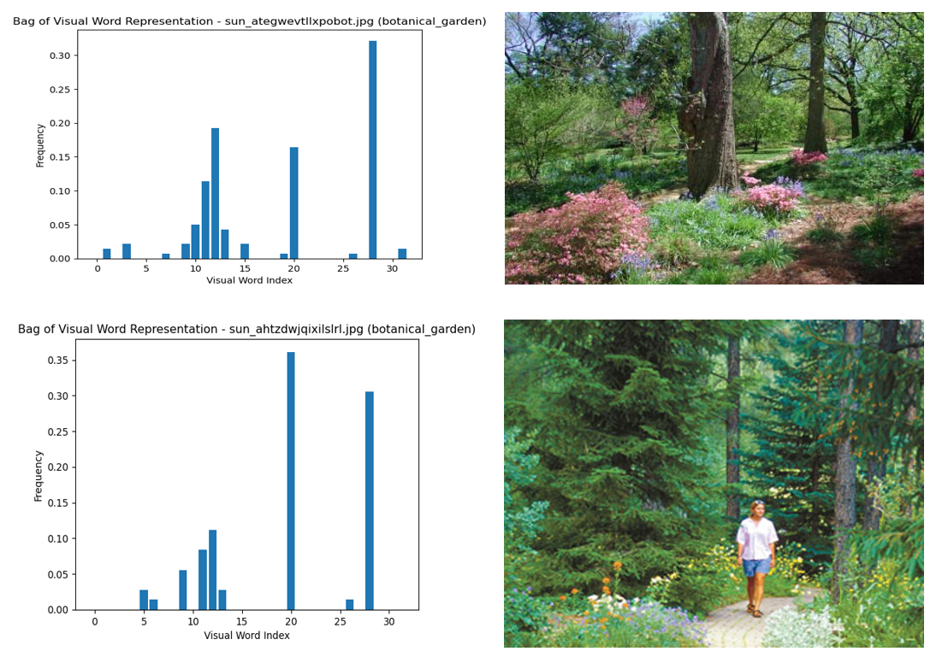
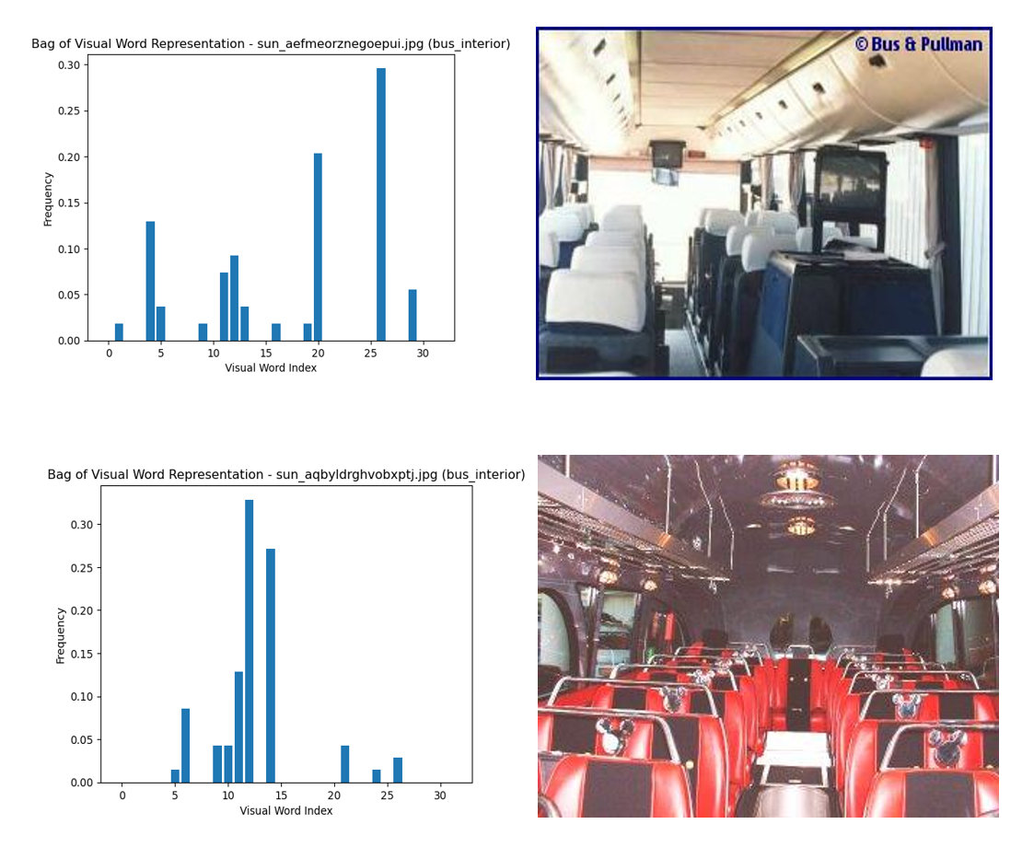
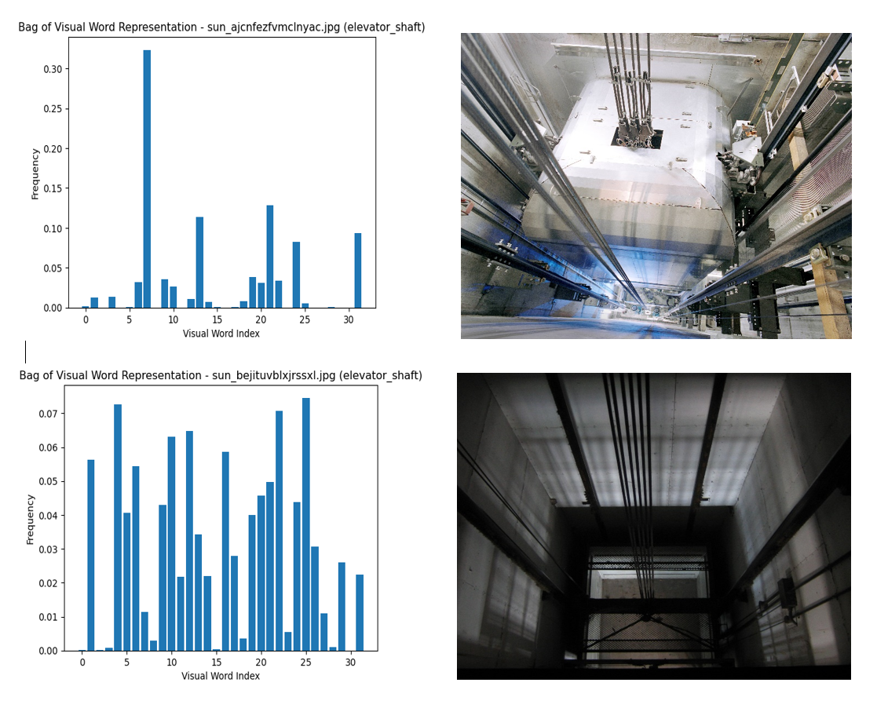

Log-Likelihood vs Iterations Plots:

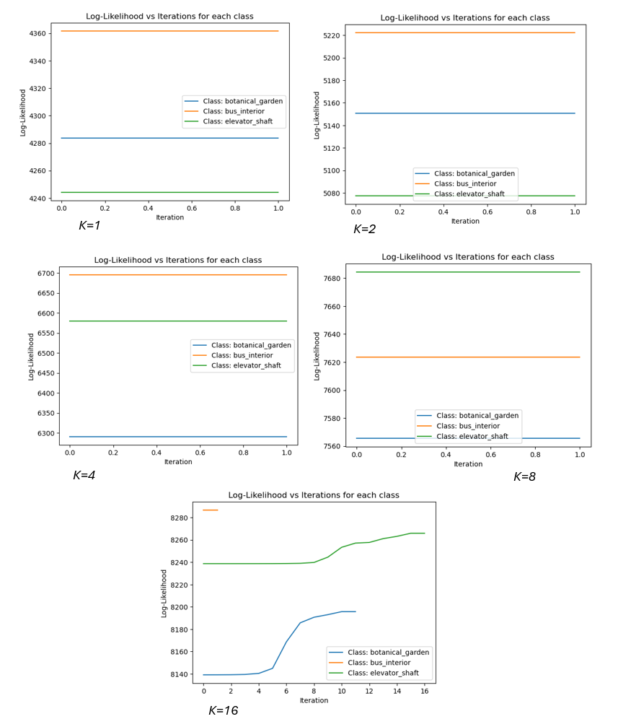

Performance Metrics:
Confusion Matrix, precision, Recall and F-measure:

Actual  Predicted Class1 Class2 Class3  Class1 40 7 3  Class2 5 37 8  Class3 5 18 27  Table 18:Confusion Matrix | Class1 Class2 Class3  Precision 0.8000 0.5968 0.7105  Recall 0.8000 0.7400 0.5400  F-Measure 0.8000 0.6607 0.6136  Table 19:Analysis

Accuracy | 69.33%
Mean Precision | 0.7024
Mean Recall | 0.6933
Mean F-Measure | 0.6915
Table 20:Resul
- GMM using 1 cluster: botanical_garden,bus_interior and elevator_shaft
Actual  Predicted Class1 Class2 Class3  Class1 28 6 16  Class2 2 24 24  Class3 3 18 29  Table 21:Confusion Matrix | Class1 Class2 Class3  Precision 0.8485 0.5000 0.4203  Recall 0.5600 0.4800 0.5800  F-Measure 0.6747 0.4898 0.4874  Table 22:Analysis

Accuracy | 54.00
Mean Precision | 0.5896
Mean Recall | 0.5400
Mean F-Measure | 0.5506
Table 23:Resul
(b) GMM using 2 cluster: botanical_garden,bus_interior and elevator_shaft
Actual  Predicted Class1 Class2 Class3  Class1 45 0 5  Class2 33 7 10  Class3 33 2 15  Table 24:Confusion Matrix | Class1 Class2 Class3  Precision 0.4054 0.7778 0.5000  Recall 0.9000 0.1400 0.3000  F-Measure 0.5590 0.2373 0.3750  Table 25:Analysis

Accuracy | 44.67%
Mean Precision | 0.5611
Mean Recall | 0.4467
Mean F-Measure | 0.3904
Table 26:Result
(c) GMM using 4 cluster: botanical_garden,bus_interior and elevator_shaft
Actual  Predicted Class1 Class2 Class3  Class1 50 0 0  Class2 50 0 0  Class3 50 0 0  Table 27:Confusion Matrix | Class1 Class2 Class3  Precision 0.3333 0.0000 0.0000  Recall 1.0000 0.0000 0.0000  F-Measure 0.5000 0.0000 0.0000  Table 28:Analysis

Accuracy | 33.33%
Mean Precision | 0.1111
Mean Recall | 0.3333
Mean F-Measure | 0.1667
Table 29:Resul
(d) GMM using 8 cluster: botanical_garden,bus_interior and elevator_shaft
Actual  Predicted Class1 Class2 Class3  Class1 50 0 0  Class2 50 0 0  Class3 50 0 0  Table 30:Confusion Matrix | Class1 Class2 Class3  Precision 0.3333 0.0000 0.0000  Recall 1.0000 0.0000 0.0000  F-Measure 0.5000 0.0000 0.0000  Table 31:Analysis

Accuracy | 33.33%
Mean Precision | 0.1111
Mean Recall | 0.3333
Mean F-Measure | 0.1667
Table 32:Resul
(d) GMM using 8 cluster: botanical_garden,bus_interior and elevator_shaft

Observations for Bag-of-Visual-Words (BoVW) Features:

Iteration vs. Log-Likelihood Plots
- Behavior of EM Algorithm:
  - For BoVW features, the log-likelihood tends to increase more gradually and requires more iterations to converge, especially for higher values of K. This is because BoVW features are more complex and capture finer details of the images, leading to a more intricate data distribution that requires more iterations to model.
  - Higher log-likelihood values are observed compared to color histograms, indicating that the GMM fits the BoVW data better. This suggests that BoVW features provide a richer representation of the images, allowing the model to better capture the underlying patterns.
- Class-wise Differences:
  - The log-likelihood values for classes like bus_interior are consistently higher, reflecting a better fit for these classes. This may be due to more distinct visual patterns present in the bus_interior images that are well-captured by the BoVW representation.
  - For classes with more visual similarity, such as coast and forest, the log-likelihood may show smaller increases with more iterations, indicating that distinguishing these classes remains challenging even with BoVW features.
Classification Performance
- Effect of K:
  - The performance of the GMM classifier improves significantly as K increases, with the best results generally achieved for higher values (e.g., K=16 or K=32). This suggests that more Gaussian components are needed to fully capture the complexity of the BoVW features.
  - Unlike color histogram features, where increasing K beyond a certain point leads to overfitting, BoVW features continue to show improvements with higher K, indicating that they benefit from a more detailed model.
- Confusion Matrix Analysis:
  - The confusion matrix for BoVW features shows better classification performance across all classes, with fewer misclassifications compared to color histograms. The BoVW representation allows for clearer distinctions between classes like coast and forest, reducing confusion.

Inferences for Bag-of-Visual-Words Features
- Log-Likelihood and EM Convergence:
  - The slower convergence of log-likelihood for BoVW features suggests that the EM algorithm is effectively refining the model parameters to fit the data. This reflects the higher complexity and richer information contained in the BoVW features.
  - When using BoVW, higher values of K (more clusters) are generally required to capture the finer details in the data, resulting in better classification performance.
- Effect of K:
  - The BoVW representation benefits more from a higher number of components compared to color histograms, indicating that it captures more detailed information about the images. Thus, a higher K is needed to model this complexity effectively.
- Class Distinction:
  - The BoVW features provide a more discriminative representation for scene classification, leading to clearer class boundaries and better overall classification results. This demonstrates the advantage of using more complex feature extraction techniques.

4.4. Dataset 2(c) (Cell Image Data)

Implementation:
The implementation for the cell image dataset involves using K-Means and Modified K-Means clustering algorithms to segment cervical cell images. The objective is to partition each image into three distinct regions: cell body, cell boundary, and background. The segmentation process is based on clustering the extracted features—mean intensity and standard deviation—from overlapping patches in the images. Below is the detailed implementation and methodology.
Preprocessing and Feature Extraction
Image Dataset
- The dataset consists of cervical cell images with varying characteristics. Each image contains different regions representing the cell body, cell boundary, and background, which need to be segmented.
- Directly using pixel values is not effective for capturing local texture and structural information; hence, feature extraction is performed to obtain meaningful representations for clustering.
Feature Extraction
- Patch Extraction:
  - Overlapping patches of size 7x7 pixels are extracted from each image. The patches move across the image with a stride of 1 pixel, ensuring a high overlap between adjacent patches. This overlap allows for capturing detailed local variations in the image.
- Feature Representation:
  - For each patch, two features are computed: the mean intensity and the standard deviation of pixel values within the patch.
  - The mean represents the overall brightness of the patch, while the standard deviation captures the local texture or intensity variations. This results in a 2-dimensional feature vector for each patch.
- Why Mean and Standard Deviation?:
  - These features are simple yet effective in distinguishing different regions in the cell images. Smooth regions (e.g., background) tend to have low standard deviation, while textured regions (e.g., cell boundaries) exhibit higher standard deviation.
- Data Storage:
  - The extracted feature vectors are stored in .npy files for efficient loading and processing during training and testing. Separate datasets are maintained for training and testing.
Clustering Using K-Means and Modified K-Means
K-Means Clustering Algorithm
- Overview:
  - K-Means is an iterative clustering algorithm that aims to partition the feature vectors into a predefined number of clusters (3 clusters in this case).
- Distance Metric:
  - Euclidean Distance is used to measure the similarity between a patch's feature vector and the cluster centers. The Euclidean distance does not account for correlations between features, assuming they are independent.
- Steps:
Initialization:
    - Cluster centers are randomly initialized. This helps in exploring different regions of the feature space and affects the final clustering outcome.
Cluster Assignment:
    - Each patch's feature vector is assigned to the cluster with the nearest center based on the Euclidean distance.
Recompute Cluster Centers:
    - The cluster centers are updated by calculating the mean of all feature vectors assigned to each cluster.
Handle Empty Clusters:
    - If any cluster has no points assigned (empty cluster), a new random data point is selected as the cluster center to keep all clusters active.
Convergence Check:
    - The algorithm iterates until the cluster centers stabilize (i.e., changes fall below a threshold), indicating convergence.

Modified K-Means Clustering Algorithm
- Overview:
  - Modified K-Means uses Mahalanobis distance as the similarity measure, which accounts for correlations between features by incorporating the covariance matrix.
- Distance Metric:
  - Mahalanobis Distance adjusts the distance based on the covariance of the features, providing a more effective clustering when features are correlated.
- Steps:
Initialization:
    - The initial cluster centers are the same as those used in the standard K-Means to ensure consistency in comparison.
Cluster Assignment:
    - For each patch's feature vector, the Mahalanobis distance to each cluster center is computed, and the patch is assigned to the nearest cluster.
Recompute Cluster Centers and Covariance:
    - The cluster centers are updated as the mean of all assigned feature vectors, and the covariance matrix for each cluster is recalculated.
Handle Empty Clusters:
    - If a cluster becomes empty, a random point is selected to replace the empty cluster center, similar to the standard K-Means procedure.
Convergence Check:
    - The algorithm iterates until the cluster centers and covariance matrices stabilize, indicating the end of the clustering process.

Image Segmentation
Load Test Image Features
- The trained clustering model is used to segment unseen test images. The extracted features for each test image are loaded and processed similarly to the training data.
Assign Test Patches to Clusters
- For each patch in the test image, the distance (Euclidean or Mahalanobis) to each cluster center is calculated.
- The patch is then assigned to the nearest cluster, effectively labeling each patch based on its similarity to the learned clusters.
Reshape Cluster Assignments into an Image
- The cluster assignments are reshaped to match the original grid structure of the image. Each patch is colored according to its cluster label, resulting in a segmented image.
- This process enables visualization of the segmented regions, corresponding to the cell body, cell boundary, and background.

Results
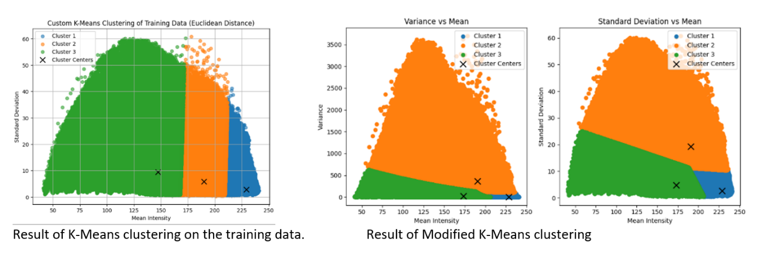
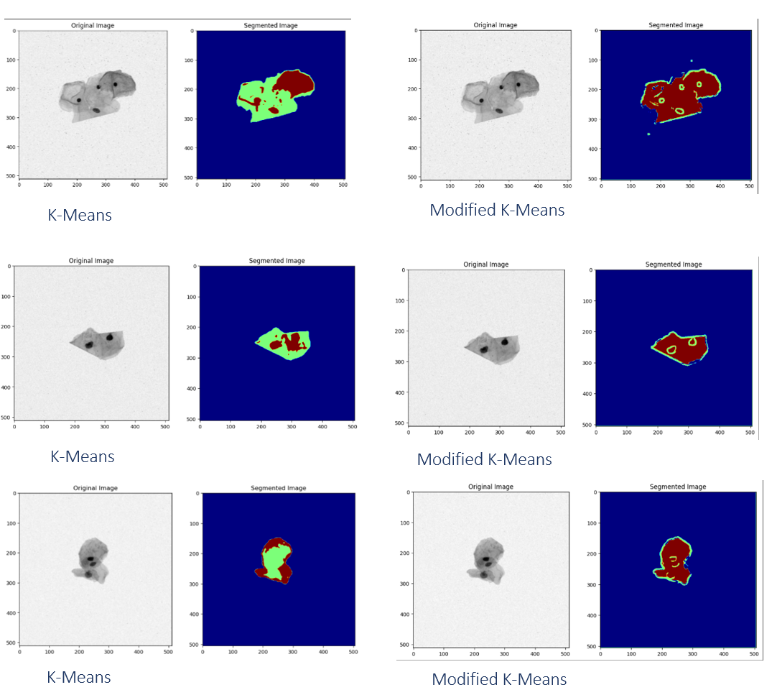

Observations:

The observations for the segmentation of cervical cell images using K-Means (with Euclidean distance) and Modified K-Means (with Mahalanobis distance) are detailed below. These observations include analysis of the clustering results, the effectiveness of feature representation, the differences between the algorithms, and the segmentation quality.

Observations from Clustering
K-Means Clustering (Using Euclidean Distance)
- Cluster Characteristics:
  - The clusters formed using K-Means exhibit clear distinctions based on the mean intensity and standard deviation of the patches.
  - Cluster 1: Represents patches with lower mean intensity and higher variance, often corresponding to cell boundaries where there is more texture.
  - Cluster 2: Represents regions with medium intensity and medium variance, likely corresponding to the cell body.
  - Cluster 3: Represents regions with higher intensity but lower variance, which are typically found in the background areas of the image.
- Convergence Behavior:
  - The algorithm generally converges within a few iterations (less than 20), indicating that the cluster centers stabilize quickly. The relatively simple decision boundaries formed by Euclidean distance lead to faster convergence.
- Handling of Feature Correlations:
  - K-Means clustering using Euclidean distance does not account for correlations between the features (mean intensity and standard deviation). As a result, some patches near the cluster boundaries are misclassified, particularly where the features are interdependent.

Modified K-Means Clustering (Using Mahalanobis Distance)
- Cluster Characteristics:
  - The clusters formed using Modified K-Means are more distinct and better adapted to the natural variations in the data.
  - Cluster 1: Characterized by relatively high standard deviation and mean intensity, corresponding to textured regions within the cell, such as cell interiors.
  - Cluster 2: Shows patches with medium standard deviation but lower mean intensity, likely representing the background or less textured regions.
  - Cluster 3: Represents cell boundaries with medium to high mean intensities and standard deviations, providing a clearer distinction between the boundary and the cell body.
- Convergence Behavior:
  - The algorithm takes slightly longer to converge compared to standard K-Means, typically requiring more iterations. This is due to the use of Mahalanobis distance, which incorporates the covariance matrix, making the decision boundaries more flexible and adaptive.
- Handling of Feature Correlations:
  - The Mahalanobis distance effectively accounts for correlations between the features, resulting in more accurate clustering. This is evident in the improved separation between clusters, particularly at the cell boundaries.

Observations from Image Segmentation
Segmentation Using K-Means (Figures 1, 3, 5, 7)
- Cluster Assignment:
  - The segmentation results show a clear separation of the cell body, boundaries, and background in most cases.
  - Cluster 1 (light green): Represents the inner regions of the cells where intensity variations are smoother.
  - Cluster 2 (brown): Captures the cell boundaries, where there are abrupt changes in intensity.
  - Cluster 3 (blue): Isolates the background, which is characterized by higher mean intensity and low variance.
- Effectiveness of Segmentation:
  - The segmentation is generally successful, but some regions appear merged or misclassified, especially near the boundaries. This is due to the linear nature of the decision boundaries formed by K-Means using Euclidean distance.
- Limitations:
  - The standard K-Means algorithm struggles with accurately segmenting regions where the features exhibit complex interdependencies. This leads to less precise boundaries, particularly in images where the texture changes are subtle.

Segmentation Using Modified K-Means (Figures 2, 4, 6, 8)
- Cluster Assignment:
  - The Modified K-Means algorithm produces a more detailed segmentation with better distinction between the regions.
  - Cluster 1 (blue): Represents regions with high mean intensity and high standard deviation, corresponding to textured areas within the cell body.
  - Cluster 2 (orange): Captures the background, where there is low mean intensity and low texture.
  - Cluster 3 (green): Corresponds to the cell boundaries, with medium to high intensity variations.
- Effectiveness of Segmentation:
  - The segmentation results are more refined compared to standard K-Means. The algorithm captures subtle texture differences, providing a clearer separation between the cell body and boundary.
  - The decision boundaries formed are quadratic in nature, allowing the model to handle non-linear separations in the data.
- Advantages Over Standard K-Means:
  - Modified K-Means successfully distinguishes overlapping regions, especially where there is a correlation between mean intensity and texture. This results in more accurate identification of the cell structure, including finer details.

Inferences from Clustering and Segmentation

Differences Between K-Means and Modified K-Means
- Decision Boundary Characteristics:
  - K-Means creates linear decision boundaries, which are less effective for data with non-linear separations. This limitation affects the segmentation quality, particularly at the boundaries.
  - Modified K-Means forms quadratic decision boundaries due to the use of Mahalanobis distance. This allows for more flexible clustering and better handling of complex data distributions.
- Handling of Feature Correlations:
  - The Mahalanobis distance in Modified K-Means captures the relationships between the mean intensity and standard deviation, leading to more accurate clustering. In contrast, K-Means with Euclidean distance treats the features independently, which can result in suboptimal segmentation.

Observations Across Test Images
- Figure 1 vs. Figure 2 (Test Image 1):
  - K-Means provides a basic segmentation of the cell body and boundary, but some regions appear merged. Modified K-Means offers a more distinct separation, effectively isolating the cell boundary and background.
- Figure 3 vs. Figure 4 (Test Image 2):
  - In smaller cell images, both algorithms segment the regions accurately, but Modified K-Means captures the boundaries more precisely, reflecting a finer distinction due to the Mahalanobis distance.
- Figure 5 vs. Figure 6 (Test Image 3):
  - For images with complex cell structures, Modified K-Means captures more details within the cell, providing better resolution in areas with subtle texture variations.
- Figure 7 vs. Figure 8 (Test Image 4):
  - The Modified K-Means algorithm successfully highlights small structures within the cell, demonstrating its ability to segment intricate details compared to the linear approach of K-Means.

Convergence Analysis
- K-Means:
  - Converges faster due to the linear nature of the decision boundaries and simpler distance calculations. Typically, fewer iterations (around 10-15) are needed.
- Modified K-Means:
  - Requires more iterations (15-25) to converge because the quadratic decision boundaries provide a more detailed fit to the data. The inclusion of the covariance matrix in distance calculations adds to the computational complexity but improves segmentation accuracy.

Summary of Observations
- K-Means Clustering:
  - Provides reasonable segmentation but struggles with feature correlation and complex boundaries.
  - Segmentation is faster but less accurate for data with non-linear separations.
- Modified K-Means Clustering:
  - Offers better segmentation quality by accounting for feature correlations using Mahalanobis distance.
  - Captures finer details in the images, especially at cell boundaries, due to more flexible decision boundaries.
- Segmentation Quality:
  - Both methods segment the cell body, boundary, and background effectively, but Modified K-Means consistently performs better, especially in distinguishing the boundary from the cell body and background.
These observations demonstrate that while both clustering algorithms can be used for image segmentation, Modified K-Means with Mahalanobis distance is more suitable for complex datasets, such as cervical cell images, where feature correlations play a significant role.

5. Comparative Analysis

Impact of Varying the Number of Mixtures K on Performance
The number of Gaussian components K plays a significant role in determining the effectiveness of GMM-based classification. The observations across all datasets regarding the choice of K are as follows:
- Small Values of K (e.g., 1 or 2):
  - When K is too small, the GMM lacks the flexibility to model the complex, multi-modal distributions of the data. This results in underfitting, where the model's decision boundaries are too simplistic to capture the variations within each class.
  - Across all datasets, using K=1K = 1K=1 or K=2K = 2K=2 led to lower classification accuracy and higher misclassification rates because a single Gaussian component per class was unable to account for the data's true distribution.
- Moderate Values of K (e.g., 8 or 16):
  - For moderate values of K, the GMM classifier is generally able to provide a good balance between capturing the data's complexity and maintaining generalization. The decision boundaries become more flexible, allowing for better representation of non-linear separations in the feature space.
  - In Dataset 1 (2D synthetic data) and Dataset 2(a) (speech data), K=8K = 8K=8 or K=16K = 16K=16 resulted in significant improvements in classification metrics such as accuracy, precision, and F1-score. The additional components allowed the model to represent the variability within each class without overfitting.
  - For Dataset 2(b) (scene images), moderate K values were particularly effective with the Bag-of-Visual-Words (BoVW) features, as the richer representation required more components to model the intricate data distribution.
- High Values of K (e.g., 32 or 64):
  - Increasing K to very high values generally led to overfitting, especially when the training data was limited. The GMM model becomes too sensitive to the noise in the training data, leading to poor generalization on the test set.
  - For Dataset 2(a), using K=32K = 32K=32 or K=64K = 64K=64 did not provide substantial improvements in accuracy and sometimes degraded performance due to overfitting. However, for Dataset 2(b) with BoVW features, higher K values continued to yield some improvements, indicating that the complex feature space benefits from a more detailed model.
  - In Dataset 2(c) (cell images), clustering with very high K values did not significantly improve the segmentation quality, as the primary structure of the images was already well captured with lower K.
Comparison Between GMM Classification Results and Assignment 1 (Datasets 1 and 2a)
- Dataset 1 (2D Synthetic Data):
  - In Assignment 1, linear classifiers were used, which resulted in lower classification performance due to the non-linear separability of the classes. The linear decision boundaries failed to effectively separate the overlapping regions in the feature space.
  - The GMM-based approach in the current assignment showed a marked improvement in accuracy by modeling non-linear decision boundaries. With K=8K = 8K=8 or K=16K = 16K=16, the GMM classifier provided flexible decision boundaries that accurately partitioned the feature space, capturing the true distribution of each class.
- Dataset 2(a) (Speech Data):
  - The linear classifiers in Assignment 1 struggled to distinguish vowel classes due to the overlapping regions in the formant frequency space. The classification results were limited by the linear nature of the decision boundaries.
  - The GMM classifier, on the other hand, showed significant improvements by adapting to the multi-modal distributions present in the data. By using multiple Gaussian components, the GMM could model the variations within each vowel class, leading to higher precision and recall. The improvements were most notable when K was set to moderate values (e.g., 8 or 16), allowing the model to capture intra-class variability.

Feature Choice for Dataset 2(b) and Clustering Approach for Dataset 2(c)
Feature Choice for Dataset 2(b) (Scene Image Dataset)
- Color Histogram Features:
  - Color histogram features provided a basic representation of the color distribution across the image. While they captured the general color characteristics, they lacked spatial information and failed to differentiate between different regions of an image based on structure.
  - The GMM classifier using color histograms showed improvement over linear methods, but the performance gains were limited compared to BoVW features. The number of Gaussian components K had a smaller impact on classification accuracy for color histograms due to the simpler nature of the feature representation.
- Bag-of-Visual-Words (BoVW) Features:
  - BoVW features offered a more sophisticated representation by capturing spatial patterns and local structures within the images. This resulted in richer feature vectors that provided the GMM classifier with more information to model the data effectively.
  - The GMM classifier performed significantly better with BoVW features, especially for higher values of K. The increased number of components allowed the model to capture the finer details in the data, leading to higher classification accuracy and more robust decision boundaries.
  - The choice of BoVW features proved advantageous for scene image classification as it allowed the GMM to leverage the spatial distribution of visual words, making it easier to distinguish between classes with similar color characteristics but different structures.
Clustering Approach for Dataset 2(c) (Cell Image Dataset)
- K-Means Clustering (Euclidean Distance):
  - The standard K-Means algorithm using Euclidean distance was able to segment the cell images into three regions: cell body, boundary, and background. However, it used linear decision boundaries, which limited its ability to handle complex data distributions where feature correlations existed.
  - The clusters formed were reasonable, but some patches near the boundaries were misclassified due to the algorithm's inability to account for the interdependence between the features (mean intensity and standard deviation).
- Modified K-Means Clustering (Mahalanobis Distance):
  - The Modified K-Means approach using Mahalanobis distance provided a better segmentation quality by incorporating the covariance matrix, which accounted for correlations between features. This resulted in more flexible quadratic decision boundaries, allowing the algorithm to accurately capture the variations in the data.
  - The segmentation results from Modified K-Means were superior, with more distinct separation between the cell body, boundary, and background. The improved handling of feature correlations led to fewer misclassifications and better delineation of the cell structure.
  - The Mahalanobis distance made the clustering approach more adaptable to the variations in cell images, which often contain subtle texture differences and varying brightness levels.

6. Conclusions

The experiments conducted across multiple datasets reveal important insights into the application of Gaussian Mixture Models (GMM) for classification and clustering tasks, as well as the impact of various feature representations. The conclusions drawn from these experiments are summarized below.
Summary of Key Findings
- GMM Classification Performance:
  - GMM-based classification significantly outperforms linear methods in datasets where classes are not linearly separable, such as the 2D synthetic data and vowel speech data. The flexibility of GMM in modeling complex, non-linear decision boundaries allows it to capture the true underlying distributions of different classes.
  - The choice of the number of Gaussian components K is critical. The experiments show that a moderate number of components (e.g., K=8 or K=16) typically provides the best trade-off between capturing the data's structure and avoiding overfitting.
- Feature Representation Impact:
  - For scene image classification (Dataset 2(b)), the Bag-of-Visual-Words (BoVW) features significantly outperform color histograms due to their ability to capture spatial and structural information, leading to more discriminative representations for GMM classification.
  - In the cell image dataset (Dataset 2(c)), using Modified K-Means with Mahalanobis distance improves segmentation quality over standard K-Means by accounting for correlations between features. This results in more accurate identification of cell boundaries and background.
- Comparative Analysis with Assignment 1:
  - The GMM-based approach showed clear improvements over the linear classifiers used in Assignment 1, especially for datasets with complex distributions. The ability of GMM to model multiple modes within each class distribution leads to better classification accuracy and more robust decision boundaries.
Importance of Selecting an Appropriate Number of GMM Components
- Effect of K:
  - The number of Gaussian components K directly impacts the classifier's performance. Small values of K lead to underfitting, where the model is too simplistic to capture the data's complexity. Conversely, very high values of K can cause overfitting, where the model becomes overly sensitive to noise in the training data, leading to poor generalization.
  - Selecting a moderate K (e.g., 8 or 16) generally provides the best results across different datasets, capturing the key patterns within the data while maintaining good generalization on unseen test samples.
- Convergence Behavior:
  - For higher K, the Expectation-Maximization (EM) algorithm requires more iterations to converge, indicating a more detailed refinement of the model parameters. This can be advantageous for complex datasets but may also increase computational cost.
Impact of Feature Representation on Classification and Clustering Performance
- Scene Image Classification (Dataset 2(b)):
  - The choice of feature representation plays a crucial role in classification accuracy. BoVW features, which encode spatial patterns and local image structures, result in better performance compared to color histograms, which only capture global color distribution.
  - Higher values of K are beneficial for BoVW features, as the complex representation requires more Gaussian components to fully model the data distribution.
- Cell Image Segmentation (Dataset 2(c)):
  - The use of Mahalanobis distance in Modified K-Means clustering significantly improves segmentation results by incorporating feature correlations into the clustering process. This approach yields better separation of cell regions, particularly at boundaries where texture and intensity are correlated.
  - Standard K-Means, using Euclidean distance, is less effective in handling such correlations, resulting in less accurate segmentation.

7. References
- Bishop, C. M. (2006). Pattern Recognition and Machine Learning. Springer.
- Duda, R. O., Hart, P. E., & Stork, D. G. (2000). Pattern Classification. Wiley.
- Murphy, K. P. (2012). Machine Learning: A Probabilistic Perspective. MIT Press.
- Mitchell, T. M. (1997). Machine Learning. McGraw-Hill.

